
CLOUD ARCHITECT

(Vendor Neutral: AWS & Azure)

Table of Contents


03 | About the Program
04 | Program features
05 | Benefits of this program
06 | Learning Path
07 | Who should enroll for this program?
07 | Why should you enroll for this program?

Vendor Neutral

Vendor neutrality is a business and design approach that seeks to ensure broad compatibility and interchangeability of products and technologies. The model encompasses standardization, non-proprietary design principles and unbiased business practices

Vendor-neutral hardware and software are designed for compatibility and interoperability. The term vendor-neutral contrasts with vendor-specific. In a vendor-specific data center, for example, hardware and software are supplied by single vendors, while in a vendor-neutral data center, technologies come from a variety of sources. Most current data centers are closer to the vendor-neutral model, although they may rely heavily upon a particular vendor.

Amazon Web Services (AWS)

The course covers Elastic Compute Cloud (EC2) VMs, Amazon Lightsail, EC2 Container Service (ECS), EC2 Container Registry, AWS Batch, RDS, Glacier, Snowball, CloudFront, DynamoDB, Redshift, Auto Scaling, CloudWatch, ElastiCache, Elastic MapReduce(EMR), CloudTrail, Cloud Search and Security.

Microsoft Azure

The course covers Azure container service, Azure VM, file storage, blob storage, table storage, CDN, ExpressRoute, SQL database, Azure AD, PowerShell, HDInsight, Azure Batch, Azure autoscaling, Azure DNS, Traffic Manager, SQL data warehouse, Azure search, Azure portal/Azure monitor.

Program features


3 years access to course content


60+ hours of live instructor-led online classes


3+ industry projects for hands-on experience

Learning Path
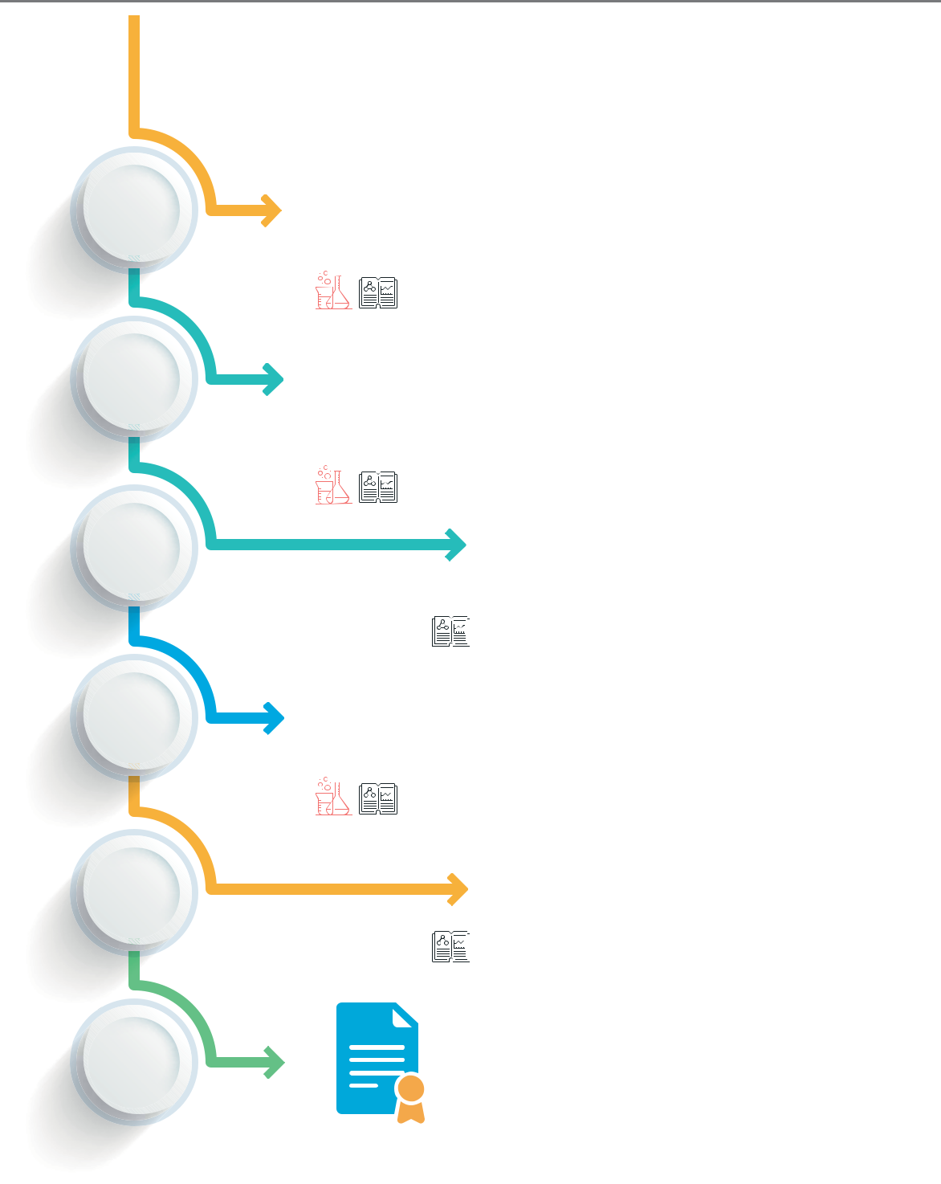

1st
week

2nd
week

3rd
week

6th
week

9th
week

13th
week

AWS Technical Essentials

Understanding AWS services, Basic concepts

AWS Developer Associate

Application development, Performance optimization, Code level application security

Developing on Azure Platform

Application development,

Performance optimization,

Code level application security

AWS Solutions Architect

Lambda, EC2, RDS, VPC, IAM, RDS

Architecting on Azure Platform

Functions, Azure container service, Virtual network, Sql database

Cloud Architect

(AWS & Azure)

Instructor-Led & Self-Paced  Instructor-Led

 Self-Paced

 Projects

 Labs

*Assumption: Your study plan is 8 hours per week

Who should enroll for this program?

This course is perfect for professionals who want to advance their careers with a deeper understanding of cloud architecture, including:

Product managers  Cloud engineers

Systems administrators Developers

IT operators, engineers, Software architects

administrators and managers

